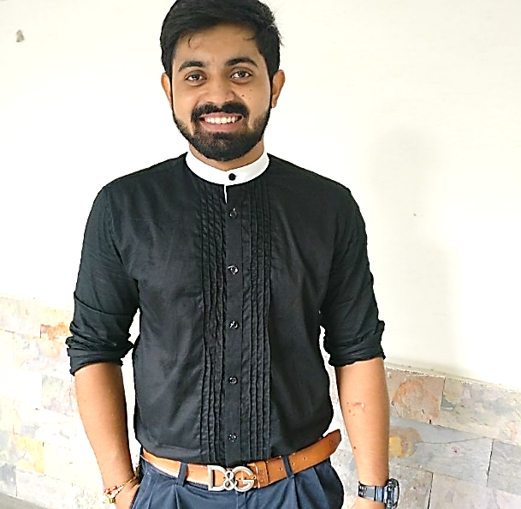

### Address

C-739,VikasPuri

First Floor, Near

Multi Gym Park

New Delhi-11018

**Specialization**

Brand Communication

Sales & Marketing

**Core Competencies**

****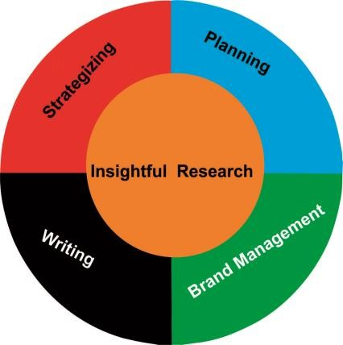

### Technical Abilities

##### MS WordFive Stars.jpg

##### MS PowerpointFive Stars.jpg

##### MS ExcelFive Stars.jpg

SHRESTH ARORA

+91-7011373628 | shrestharora.asm@gmail.com

.....

# Objective

##### To plan and implement the best marketing strategy for leading brands with the help of insights based out of research and information and using best of my skills of relationship building and brand management.

**Education**

|  |  |  |  |
| --- | --- | --- | --- |
| **Degree** | **School / University** | **Year** | **Percentage / CGPA** |
| **PGDM** | Apeejay School of Management, Dwarka | 2016-18 | 62% |
| **BCA** | VIPS, GGSIPU | 2013 – 16 | 60% |
| **HSC** | Indraprastha International School, Dwarka, CBSE Board | 2012 – 13 | 68 % |
| **SSC** | Indraprastha International School, Dwarka, CBSE Board | 2010 – 11 | 8.0 |

**Experience**

|  |  |  |
| --- | --- | --- |
| 02/04/18 (Present) | ITC Pvt Ltd  (Job- Area Executive  Modern Trade) | To handle key accounts of ITC ltd, increase sales and visibility at Modern Trade Outlets and lead a team, and handle the supply Chain. |
| 19/02/17 to 30/04/17 | Corporatedge Serviced offices  (Internship) | Understanding the Company and handelling the operations, and Client Requirements. |
| 15/02/16 to 1/09/16 | Frankly Me  (Internship) | Business Developer (North India): Building marketing communications for different campaigns; content development. |

**Personal Skills**

**­**

**Blog**

<https://www.zomato.com/tr/shresthfoodlover>

**Personal details**

##### Date of birth:

##### 09/12/1994

##### Fathersname:

##### Mr. Om Prakash Arora

##### Languages known:

##### English, Hindi, Punjabi

**DECLARATION**

I Shresth Arora, hereby declare that the details provided in this resume are correct and I have knowingly not omitted or misrepresented any information.

# Extra Curriculars

* Participation in Sports: Football, Cricket and Volleyball .
* Participation in Street Plays and Debates.
* Anchoring for college and university events.
* Event manager for fests in University.
* Became part of an orchestra with British Council.

# Achievements/ Awards

* Debate competition winner at Apeejay School of Management in 2017
* Winner for Table tennis, Volleyball and tug of war at SYNERGY 2016 and SYNERGY 2017.
* Debate competition winner at BVP Delhi in 2016.
* Bronze medal winner for debating society of our college(VIPS) in 2015.
* Runner up in a stress interview competition at GRAVITY 2015(VIPS).
* GGSIPU football title winner in 2015.